**Department of Electronics and Communication Engineering**

**Operating System And Embedded System Design**

Team A7

**REVIEW – 2**

**Review Statement :** Preemptive - Write a C program to demonstrate the concept of task switching mechanisms for 3 tasks.

1st Task - Seven segment-- 0 to 9

2nd Task- DC motor clockwise

3rd Task- UART 11 to 20 respectively.

1. ANURAG KAREHONNA 02FE21BEC009

2. ANUSHA KAMAT 02FE21BEC011

3. BHUVANESHWARI R 02FE22BEC022

4. OMKAR KHICHADI 02FE21BEC054

Under the Guidance of Prof. V.R. Dodamani

Guide Signature

1

**CODE:**

#include <lpc21xx.h>

#include <rtl.h>

#include <stdio.h>

void sev(void);

void lcd(void);

void cmd(unsigned int);

void data(unsigned int);

void delay(unsigned int);

void delay1(void);

void uart_init(void);

void init_serial(void);

unsigned int counter1, i,k;

char arr1[20];

unsigned char *ptr;

unsigned char arr[] = "11 12 13 14 15 16 17 18 19 20\n";

unsigned int b;

unsigned int Disp[16]={0x003F0000, 0x00060000, 0x005B0000,0x004F0000, 0x00660000,0x006D0000,0x007D0000, 0x00070000, 0x007F0000, 0x006F0000}; //unsigned char i;

__task void job1 (void);

__task void job2 (void);

__task void job3 (void);

__task void job1 (void)

{

os_tsk_create (job2, 0); /* Create task 2 and mark it as ready */ /* loop forever */

while(1)

{

sev() ;

}

}

__task void job2 (void)

{

os_tsk_create (job3, 0);

IODIR0=0xf0ff0000; // making po.16 to p0.23 and p0.28 to p0.31 output lines IOSET0=0xf0000000;

for(i=0;i<10;i++)

{

IOSET0 |=Disp[i];

delay1();

delay1();

delay1();

delay1();

IOCLR0=0x00ff0000;

sev()

}

2

__task void job3 (void)

{

os_tsk_create (job3, 0);

IO0DIR= 0X00000900;

IO0SET= 0X00000100;

while(1)

{

IO0CLR = 0x00000100;

for(k=0;k<1000000;k++);

IO0SET = 0X00000900;

for(k=0;k<1000000;k++);

IO0CLR = 0X00000100;

for(k=0;k<1000000;k++);

IO0SET = 0X00000900;

}

}

void sev(void)

{

while(1)

{

uart_init();

ptr = arr;

while(*ptr != '\0' )

{

U0THR = *ptr++;

while(!(U0LSR & 0x20)==0x20); for ( b=0; b<=600; b++);

}

for ( b=0; b<=60000; b++);

job3();

}

}

void uart_init(void)

{

/*PINSEL0 = 0Z0000005;

U0LCR = 0Z0000005;

U0DLM = 0Z00;

U0DLL = 0x13;

U0LCR = 0Z0000005;*/

PINSEL0 = 0x00000005;

U0LCR = 0x83;

U0DLL = 0x61;

U0LCR = 0x03;

U0IER = 0x01;

}

void delay1(void)

{

unsigned long int j;

for(j=0;j<6500000;j++);

}

3

int main (void)

{

os_sys_init (job1);

while(1);

}

**IMPLEMENTATION**

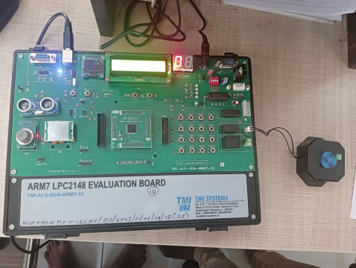4